# **Lembar Kerja Peserta Didik**

# **LKPD Sesi 10 (Setelah PTS)**

|  |  |
| --- | --- |
| Nama | : Luqman Amirullah |
| Kelas | : XI PPLG 1 |
| Materi | : Memahami teknologi aplikasi web server & Menerapkan input User pada PHP |

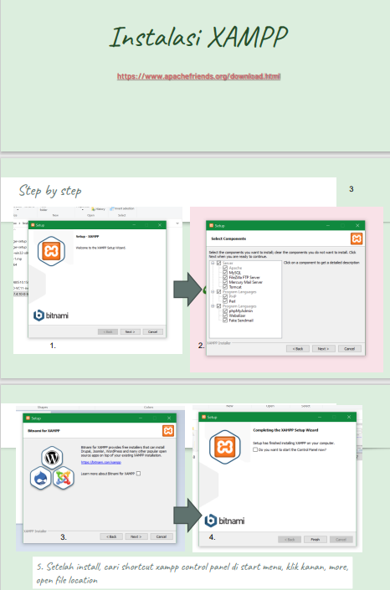

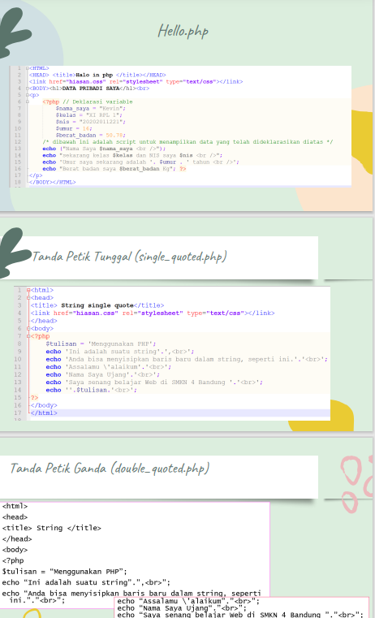 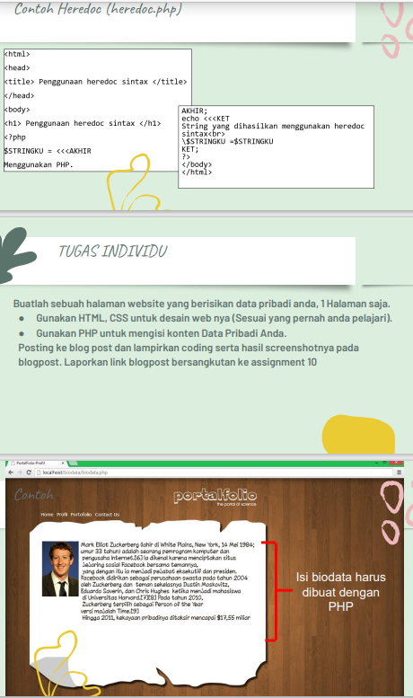

Dst materi full ada di sini 🡪: [klik aku](https://drive.google.com/file/d/1-vGYPQoOikLiuwgK9uz2LYThQui9GT8p/view?usp=sharing)

|  |
| --- |
| Hasil Tampilan hello.php |
|  |
| Source code nya :  <!DOCTYPE html>  <html lang="en">  <head>      <meta charset="UTF-8">      <meta http-equiv="X-UA-Compatible" content="IE=edge">      <meta name="viewport" content="width=device-width, initial-scale=1.0">      <link rel="stylesheet" href="./style/news.css">      <title>Berita Terkini! By Luqman Amirullah</title>      <?php          $title = $_POST['title'];          $content = $_POST['content'];          $writer = $_POST['name-author'];          $time = $_POST['time'];          $date = $_POST['date'];      ?>  </head>  <body>      <div class="container">          <h1 class="title">              <?php                  echo $title;              ?>          </h1>          <p class="author">              <?php                  echo "By: $writer, $date, $time";              ?>          </p>          <p class="content">              <?php                  echo "$content"              ?>          </p>      </div>  </body>  </html> |

|  |
| --- |
| Hasil Tampilan Tanda Petik Tunggal (single_quoted.php) |
|  |
| Source code nya :  <!DOCTYPE html>  <html lang="en">  <head>      <meta charset="UTF-8">      <meta http-equiv="X-UA-Compatible" content="IE=edge">      <meta name="viewport" content="width=device-width, initial-scale=1.0">      <title>String Single Qoute By Luqman Amirullah</title>  </head>  <body>      <?php          $tulisan = 'Menggunakan PHP';          echo 'Ini adalah suatu string '.', <br >';          echo 'Anda bisa menyisipkan baris baru dalam string, seperti ini.'.'<br>';          echo 'Assalamu \' alaikum'.'<br>';          echo 'Nama Saya Luqman'.'<br>';          echo ''.$tulisan.' <br>';      ?>  </body>  </html |
| Hasil tampilan Tanda Petik Ganda (double_quoted.php) |
|  |
| Source code nya :  <!DOCTYPE html>  <html lang="en">  <head>      <meta charset="UTF-8">      <meta http-equiv="X-UA-Compatible" content="IE=edge">      <meta name="viewport" content="width=device-width, initial-scale=1.0">      <title>Double Quote In PHP By Luqman Amirullah</title>  </head>  <body>      <?php          $tulisan = " Menggunakan PHP ";          echo "Ini adalah suatu string".",<br>";          echo "anda bisa menyisipkan baris baru dalam string seperti ini"."<br>";          echo "Assalamu'alaikum "."<br>";          echo "Nama Saya Luqman"."<br>";          echo "Saya senang belajar Web di SMKN 4 Bandung"."<br>";          echo "$tulisan"."<br>";      ?>  </body>  </html> |
| Hasil Tampilan Contoh Heredoc (heredoc.php) |
|  |
| Source code nya :  <!DOCTYPE html>  <html lang="en">  <head>      <meta charset="UTF-8">      <meta http-equiv="X-UA-Compatible" content="IE=edge">      <meta name="viewport" content="width=device-width, initial-scale=1.0">      <title>Pengunaan Heredoc sintax By Luqman Amirullah</title>  </head>  <body>      <h1>Penggunaan heredoc sintax</h1>      <?php          $STRINGKU = <<<AKHIR          Menggunakan PHP.          AKHIR;          echo <<<KET          String yang dihasilkan dari sintax heredoc <br>          \$STRINGKU = $STRINGKU          KET;      ?>  </body>  </html> |
| Hasil Tampilan tugas individu portalfolio php with css |
|  |
| Source code nya :  <!DOCTYPE html>  <html lang="en">  <head>      <meta charset="UTF-8">      <meta http-equiv="X-UA-Compatible" content="IE=edge">      <meta name="viewport" content="width=device-width, initial-scale=1.0">      <link rel="stylesheet" href="./style/style.css">      <link rel="preconnect" href="https://fonts.googleapis.com">      <link rel="preconnect" href="https://fonts.gstatic.com" crossorigin>      <link href="https://fonts.googleapis.com/css2?family=Concert+One&family=Rubik+Bubbles&display=swap" rel="stylesheet">      <title>My Biodata By Luqman Amirullah</title>  </head>  <body>      <nav class="navbar">      <header class="header">          <h1 class="title">              <?php                  $title = 'Portofolio';                  echo $title;              ?>          </h1>          <p class="subtitle">              <?php                  $subtitle = 'By Luqman Amirullah';                  echo $subtitle;              ?>          </p>      </header>          <ul class="nav-ul">              <li class="nav-li">Home</li>              <li class="nav-li">Profil</li>              <li class="nav-li">Portofolia</li>              <li class="nav-li">Contact Us</li>          </ul>      </nav>      <section class="hero">          <div class="hero_item">              <h1 class="title-hero">                  <?php                      $title_hero = 'Hello My Name is';                      echo $title_hero;                  ?>                  <span class="name">                      <?php                          $name = 'Luqman Amirullah';                          echo $name;                      ?>                  </span>              </h1>              <div class="text-introduce">                  <p >                      <?php                          $text = 'Now I am studying in SMKN 4 Bandung, my hoby is sleep and eat hahaha. I currently learnig about  PHP programming language.';                          echo $text;                      ?>                  </p>              </div>          </div>          <div class="hero_item">              <img src="./asstes/cowok3d.png" alt="ilustration by freepik" width="300px">          </div>        </section>    </body>  </html> |
| Hasil Tampilan latihanpostdanprosespost |
|  |
| Source code nya :  latihanPost.php  <!DOCTYPE html>  <html lang="en">  <head>      <meta charset="UTF-8">      <meta http-equiv="X-UA-Compatible" content="IE=edge">      <meta name="viewport" content="width=device-width, initial-scale=1.0">      <title>Form Post PHP By Luqman Amirullah</title>  </head>  <body>      <form action="prosesPost.php" method="Post">          Nama: <br>          <input type="text" name="nama"><br>          Alamat: <br>          <input type="text" name="alamat">          <input type="submit" value="Submit">      </form>  </body>  </html>  prosesPost.php  <!DOCTYPE html>  <html lang="en">  <head>      <meta charset="UTF-8">      <meta http-equiv="X-UA-Compatible" content="IE=edge">      <meta name="viewport" content="width=device-width, initial-scale=1.0">      <title>Result of Form latihanPost.php By Luqman Amirullah</title>  </head>  <body>      <p id="hasil">          <?php              $nama = $_POST['nama'];              $alamat = $_POST['alamat'];              echo 'Hello '.$nama.'<br>';              echo ''.$alamat.' pasti adalah alamatmu';          ?>      </p>  </body>  </html> |
| Hasil Tampilan latihangetdanprosesget |
|  |
| Source code nya :  latihanGet.php  <!DOCTYPE html>  <html lang="en">  <head>      <meta charset="UTF-8">      <meta http-equiv="X-UA-Compatible" content="IE=edge">      <meta name="viewport" content="width=device-width, initial-scale=1.0">      <title>Get PHP By Luqman Amirullah</title>  </head>  <body>      <form action="prosesGet.php" method="get">          Nama: <br>          <input type="text" name="nama"> <br>          Alamat: <br>          <input type="text" name="alamat">          <input type="submit" value="Submit">      </form>  </body>  </html>  prosesGet.php  <!DOCTYPE html>  <html lang="en">  <head>      <meta charset="UTF-8">      <meta http-equiv="X-UA-Compatible" content="IE=edge">      <meta name="viewport" content="width=device-width, initial-scale=1.0">      <title>Proses Get By Luqman Amirullah</title>  </head>  <body>      <p id="hasil">          <?php              $nama = $_GET['nama'];              $alamat = $_GET['alamat'];              echo 'Hello'.$nama.'<br>';              echo 'ini alamat mu akan: '.$alamat.'<br>';              echo 'dan ini pakai method get loh';          ?>      </p>  </body>  </html> |

|  |
| --- |
| Hasil Tampilan studikasus 1 registrasi dan lihat.php |
|  |
| Source code nya :  registrasi.php  <!DOCTYPE html>  <html lang="en">  <head>      <meta charset="UTF-8">      <meta http-equiv="X-UA-Compatible" content="IE=edge">      <meta name="viewport" content="width=device-width, initial-scale=1.0">      <title>Registrasi PHP By Luqman Amirullah</title>  </head>  <body>      <h1>Registrasi</h1>      <form action="lihat.php" method="post">          First Name:<input type="text" name="first_name" >          Last Name:<input type="text" name="last_name"> <br>          Date of Birth Day: <input type="date" name="dbd"> <br>          Sex : <input type="radio" name="sex" value="Male"> Male <input type="radio" name="sex" value="Famale"> Famale <br>          Religion:          <select name="religion">              <option value="Islam">Islam</option>              <option value="Katolik">Katolik</option>              <option value="Protestan">Protestan</option>              <option value="Hindu">Hindu</option>              <option value="Budha">Budha</option>              <option value="Konghucu">Konghucu</option>          </select> <br>          Alamat:          <textarea name="adress" id="" cols="30" rows="1"></textarea>          <input type="submit" value="Register">      </form>  </body>  </html>  Lihat.php  <!DOCTYPE html>  <html lang="en">  <head>      <meta charset="UTF-8">      <meta http-equiv="X-UA-Compatible" content="IE=edge">      <meta name="viewport" content="width=device-width, initial-scale=1.0">      <title>Data Registrasi By Luqman Amirullah</title>  </head>  <body>      <p id="hasil">          <?php              $first_name = $_POST['first_name'];              $last_name = $_POST['last_name'];              $dbd = $_POST['dbd'];              $sex = $_POST['sex'];              $religion = $_POST['religion'];              $adress = $_POST['adress'];              $full_name = ''.$first_name.' '.$last_name;              echo 'Selamat datang '.$full_name.' anda telah berhasil daftar. Data diri anda: <br>';              echo 'Tanggal Lahir: '.$dbd.'<br>';              echo 'Jenis Kelamin: '.$sex.'<br>';              echo 'Agama: '.$religion.'<br>';              echo 'Alamat: '.$adress.'<br>';          ?>      </p>  </body>  </html> |

|  |
| --- |
| Hasil Tampilan studikasus 2 newpost + viewpost |
|  |
| Source code nya :  NewPost.php  <!DOCTYPE html>  <html lang="en">  <head>      <meta charset="UTF-8">      <meta http-equiv="X-UA-Compatible" content="IE=edge">      <meta name="viewport" content="width=device-width, initial-scale=1.0">      <link rel="stylesheet" href="./style/blog.css">      <title>Blog By Luqman Amirullah</title>  </head>  <body>      <form action="ViewPost.php" method="post" class="blog-input">          <div class="edit-text">              <input type="text" name="title" class="input-title" id="title" required >              <label for="title" class="title-label">Title</label>              <textarea type="text" name="content" class="content" rows="50" placeholder="type your content here..." required></textarea>          </div>          <div class="bar-tab">              <input type="submit" class="publish-btn" value="Publish">              <div class="option-author">                  <div class="writer">                      <input type="text" name="name-author" class="name-author" id="author" required>                      <label for="author" class="title-author">Writer</label>                  </div>                  <div class="publishedOn">                      <h4 class="h1-published">Published On:</h4>                      <label for="time">Time:</label>                      <input type="time" name="time" id="time" class="input-time" required> <br><br>                      <label for="date">Date:</label>                      <input type="date" name="date" id="date" class="input-time" required>                  </div>              </div>          </div>      </form>  </body>  </html>  ViewPost.php  <!DOCTYPE html>  <html lang="en">  <head>      <meta charset="UTF-8">      <meta http-equiv="X-UA-Compatible" content="IE=edge">      <meta name="viewport" content="width=device-width, initial-scale=1.0">      <link rel="stylesheet" href="./style/news.css">      <title>Berita Terkini! By Luqman Amirullah</title>      <?php          $title = $_POST['title'];          $content = $_POST['content'];          $writer = $_POST['name-author'];          $time = $_POST['time'];          $date = $_POST['date'];      ?>  </head>  <body>      <div class="container">          <h1 class="title">              <?php                  echo $title;              ?>          </h1>          <p class="author">              <?php                  echo "By: $writer, $date, $time";              ?>          </p>          <p class="content">              <?php                  echo "$content"              ?>          </p>      </div>  </body>  </html>  Css:  *{      margin: 0;      padding: 0;  }  .blog-input{      width: 100%;      display: flex;      flex-wrap: wrap;      position: relative;  }  .edit-text{      width: 70vw;      display: flex;      flex-direction: column;  }  .input-title{      margin-left: 20px;      font-size:15px;      padding:10px 10px 5px 5px;      margin-top: 10px;      display:block;      width:100%;      border: none;      border-bottom:2px solid orange;      position: relative;  }  .input-title:focus {      outline: none;  }  .title-label{      font-size: 20px;      position: absolute;      top: 10px;      left: 20px;      color: gray;      transition: 0.2s ease all;      cursor: text;  }  .input-title:focus ~ .title-label, input:valid ~ .title-label {      top: 5px;      font-size: 10px;      color: orange;  }  .content{      padding: 10px;      margin-top: 20px;      width: 70%;      margin-right: auto;      margin-left: auto;      height: 80vh;      border: 1px solid rgba(0, 0, 0, 0.09);      border-radius: 5px;      resize: none;  }  .content:focus{      outline: none;  }  .bar-tab{      position: relative;      width: 20vw;      display: flex;      flex-direction: column;  }  .publish-btn{      top: 25px;      right: 130px;      position: absolute;      width: 70px;      height: 30px;      border: none;      background-color: orange;      color: white;  }  .option-author{      position: absolute;      padding: 20px 10px 20px 10px;      top: 70px;      right: -50px;      width: 100%;      height: 76vh;      border: 1px solid rgba(0, 0, 0, 0.3);  }  .writer{      width: 80%;      padding: 10px;      border: 1px solid rgba(0, 0, 0, 0.09);      border-radius: 10px;      position: relative;  }  .title-author{      color: grey;      position: absolute;      top: 30px;      font-size: 15px;      transition: 0.2s ease all;      cursor: text;  }    .name-author{      margin-top: 20px;      font-size:15px;      padding:10px 10px 5px 5px;      margin-top: 10px;      display:block;      width:80%;      border: none;      border-bottom:2px solid gray;      position: relative;  }  .name-author:focus{      outline: none;  }  .name-author:focus ~ .title-author, .name-author:valid ~ .title-author{      top: 15px;      color: orange;      font-size: 10px;  }  .publishedOn{      margin-top: 20px;      margin-left: 10px;  }  .h1-published{      margin-bottom: 10px;  }  .input-time{      width: 100px;  }  body{      padding: 10px;  }  .container{      padding: 20px;      width: 60vw;      height: 100vh;      margin-left: auto;      margin-right: auto;      border: 1px solid rgba(0, 0, 0, 0.09);      border-radius: 5px;      box-shadow: -1px 1px 25px 15px rgba(0, 0, 0, 0.09);      display: flex;      flex-direction: column;      align-items: center;    }  .title{      width: 80%;      text-align: start;  }  .author{      font-size: 10px;      width: 80%;      text-align: end;  }  .content{      width: 80%;      font-size: 15px;      line-height: 1.25rem;      text-align: justify;  } |

1. Rubrik Penilaian

* Persiapan Kerja

|  |  |  |
| --- | --- | --- |
| **ASPEK YANG DINILAI** | **KATEGORI** | **NILAI** |
| 1. Internet 2. PC /Laptop 3. IDE : Notepad ++ / Sublime / Xampp | Melakukan instalasi program yang dibutuhkan | 100 |
| Menyiapkan alat namun belum melakukan instalasi program yang dibutuhkan | 75 |
| Semua sistematika dan cara kerja tidak sesuai dengan prosedur kerja | 0 |

* Proses Kerja

|  |  |  |
| --- | --- | --- |
| **NO** | **KOMPONEN** | **INDIKATOR** |
| 1 | Melakukan Praktikum | Mengerjakan praktikum dan studi kasus (challenge) |

Jika hasil kerja memenuhi indikator maka nilai maksimal = 1 Nilai = (JumlahSkor Perolehan / 9) x 100

* Hasil Kerja

|  |  |  |
| --- | --- | --- |
| **ASPEK YANG DINILAI** | **KATEGORI** | **NILAI** |
| Kelengkapan Praktikum dan studi kasus yang dikerjakan | Laporan memiliki hasil praktikum yang lengkap dan hasil pengerjaan sesuai arahan | 100 |
| Laporan memiliki hasil praktikum yang lengkap dan hasil pengerjaan kurang sesuai arahan | 80 |
| Laporan memiliki hasil praktikum yang kurang lengkap dan hasil pengerjaan sesuai arahan | 75 |
| Laporan praktikum tidak dikerjakan | 0 |

* Sikap

|  |  |  |
| --- | --- | --- |
| **ASPEK YANG DINILAI** | **KATEGORI** | **NILAI** |
| Sikap selama pengerjaan tugas | Bekerja Mandiri dan percaya diri | 100 |
| Bekerjasama dengan siswa lain dalam soal individu | 80 |
| Menggunakan contekan selama pengerjaan tugas soal individu | 75 |
| Tidak mengerjakan kegiatan / tugas | 0 |

* Waktu

|  |  |  |
| --- | --- | --- |
| **ASPEK YANG DINILAI** | **KATEGORI** | **NILAI** |
| Waktu penyelesaian tugas | Menyelesaikan tugas sebelum waktu  yang ditentukan | 100 |
| Menyelesaikan tugas sesuai waktu yang ditentukan | 80 |
| Menyelesaikan tugas sesudah waktu yang ditentukan | 75 |
| Tidak menyelesaikan tugas | 0 |

* Perhitungan nilai praktek

|  |  |  |  |  |  |
| --- | --- | --- | --- | --- | --- |
|  | PERSENTASI BOBOT PENILAIAN | | | | |
| PERSIAPAN | PROSES | HASIL | SIKAP | WAKTU |
| BOBOT(%) | 10 | 50 | 20 | 10 | 10 |
| SKOR |  |  |  |  |  |
| NK |  |  |  |  |  |

Keterangan :

Bobot diisi dengan prosentase setiap komponen

NK = Nilai Komponen, perkalian dari bobot dengan skor komponen

NP = penjumlahan dari hasil perhitungan nilai komponen

Nilai = (∑ Skor Perolehan / Skor maksimal ) x Bobot